Project name :- Uplift Lawn Service

Types of User:- Admin, Manager, Customer

Login type:- Admin, Manager are login type users

Non-login user:- Customer is a non-login user

Project Details:-

This project provides the facility for customer user to purchase services for taking care of their garden, lawn and to beautify them by their available services. Customer can place order and as per the defined frequency the service will be provided to the customer.

**Placing Order by User**

Customer, Admin and Manager user can place order.

1. The Home screen shows different services as below:-

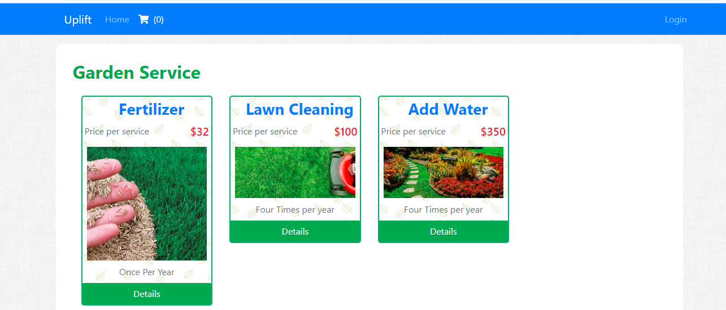

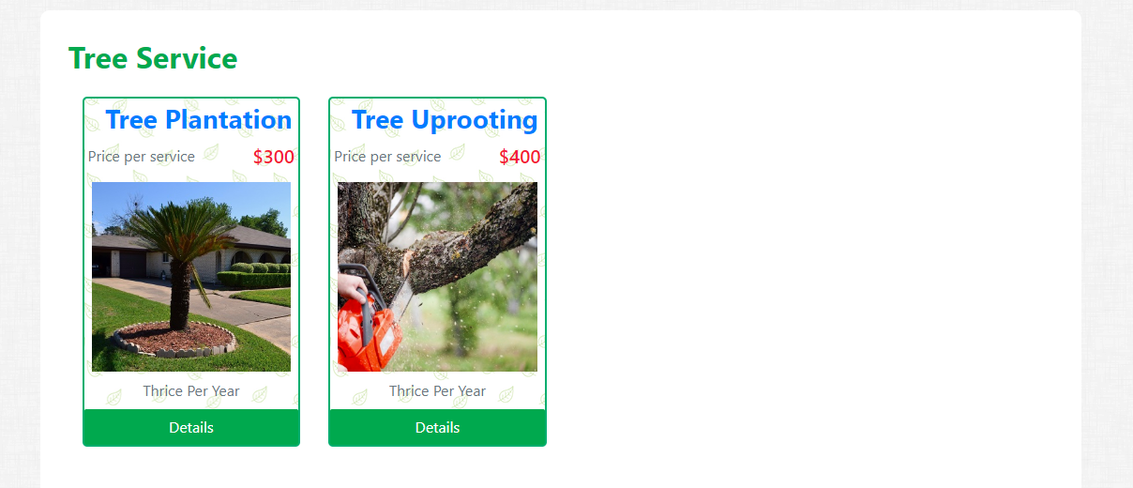

1. After clicking on details of one service, user goes to below screen. Here, User can select the specific service by clicking on “Add to Cart”. By clicking “Back to List” user comes back to the main list where all services displaying.

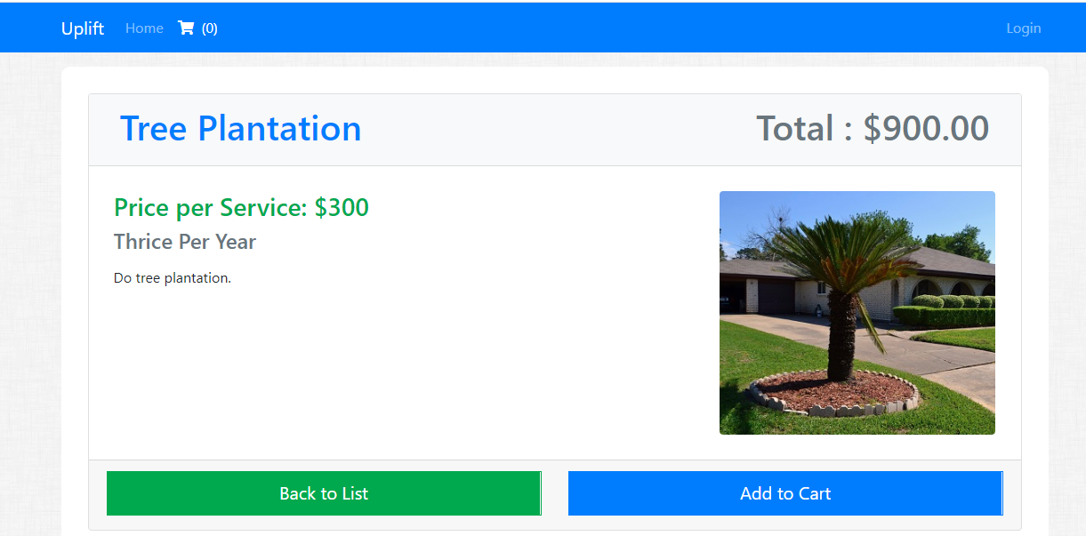

1. After clicking “Add to Cart”, user comes back to Dashboard and here the cart will show as “(1)”. Previously it was “(0)”.

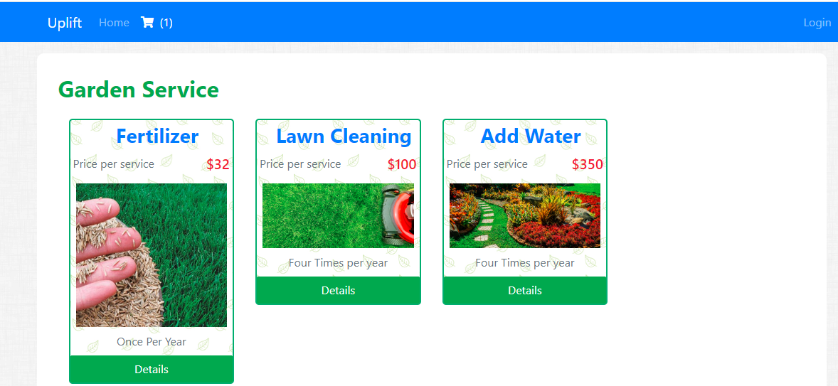

1. If user again goes to same item, then user can see the below screen. Here the button “Add to Cart” changed to “Item in Cart”. Here the total amount for that service is displaying as per the frequency(number of times).

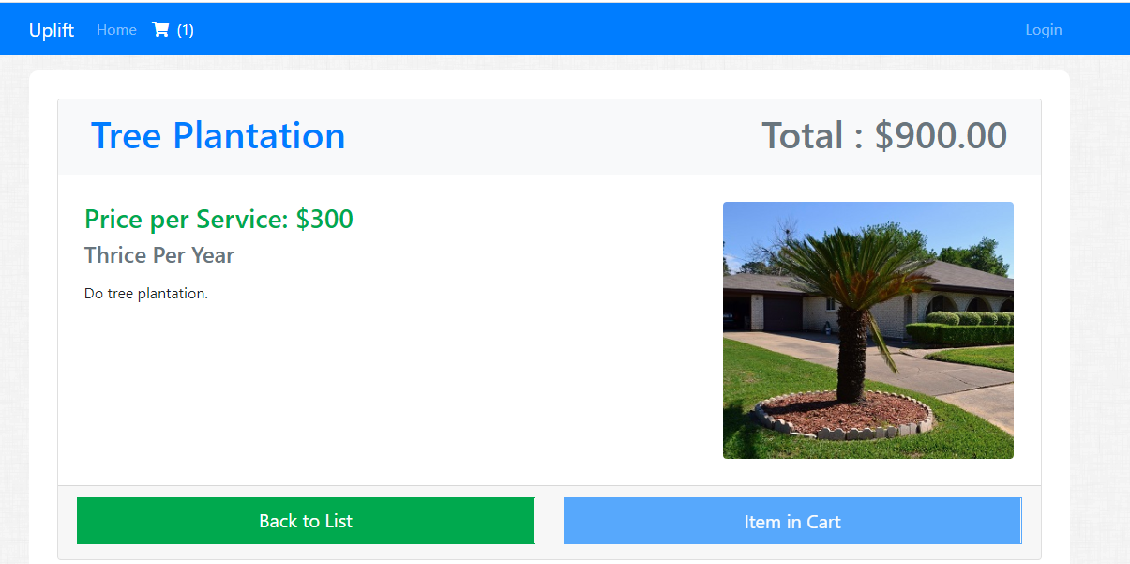

1. Same like user can add multiple items. And after adding those, user can click on Cart icon in top bar to see all the items in cart. Here, user have option to remove items from cart and user can see the total amount.

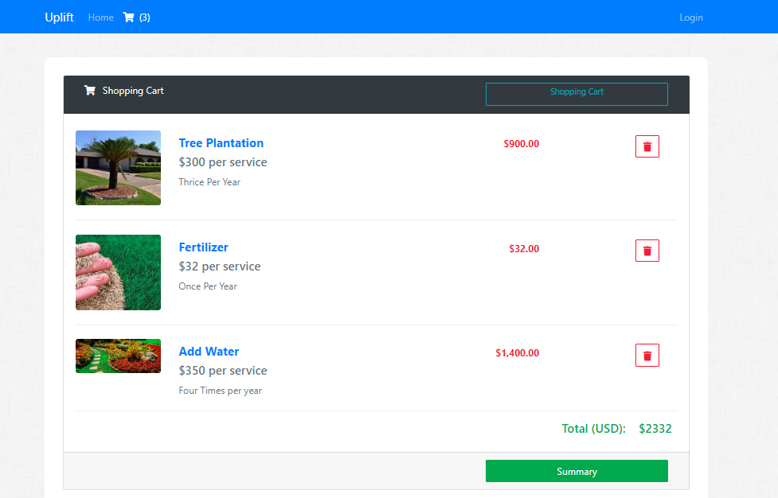

1. By clicking “Summary”, user can redirect to order summary and need to fill the pickup details for placing the order. User can come again back to cart by clicking “Back to Cart”.

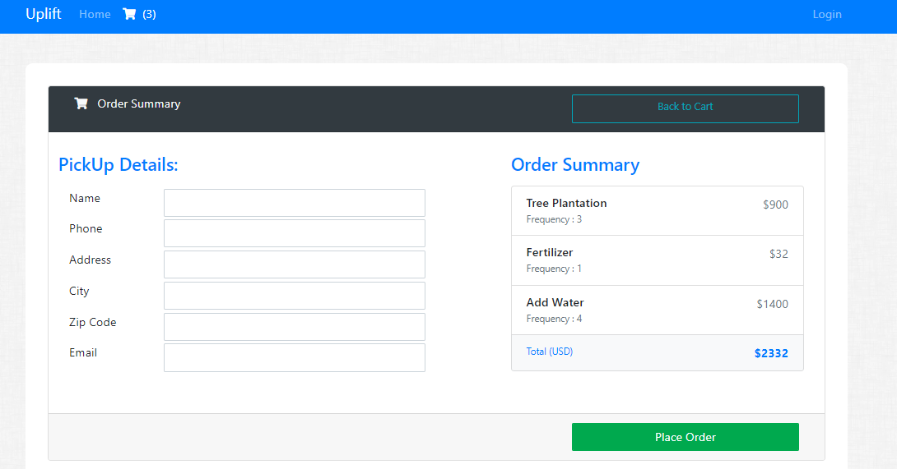

1. After filling the Pickup Details and clicking “Place Order”, user to redirect to below screen and it will generate a unique “request number”.

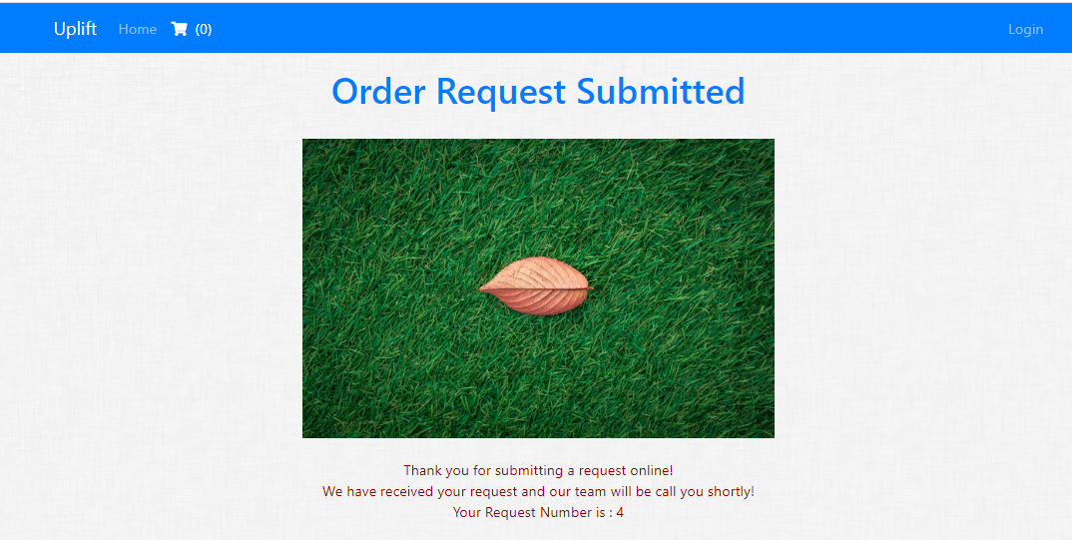

**Login Screen**

Currently Admin and Manager role users are able to login with valid credentials.

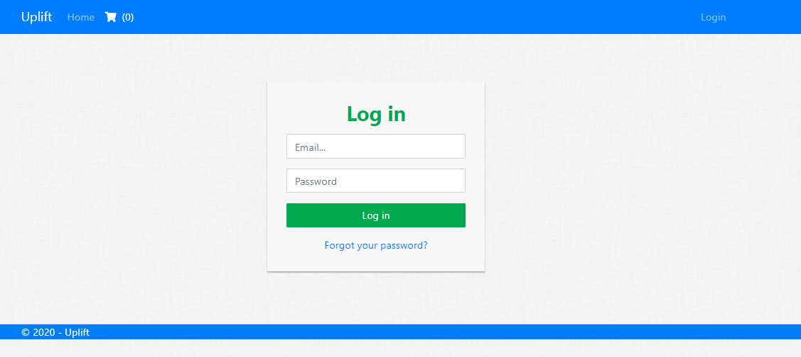

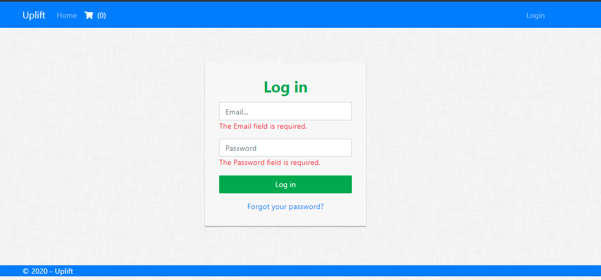

**Admin User**

After log in, Admin user can see the below screen. Here, “Manage Action” is the menu where admin user can perform different actions. In the top right corner, logged in Admin username with logout icon displaying.

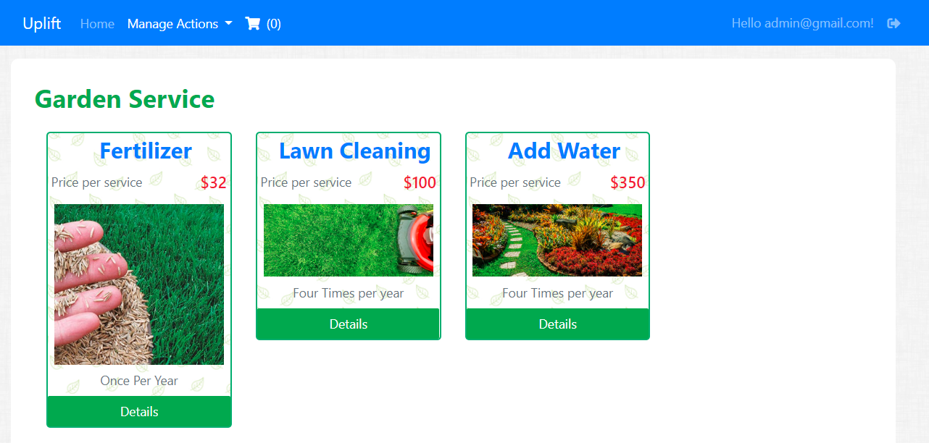

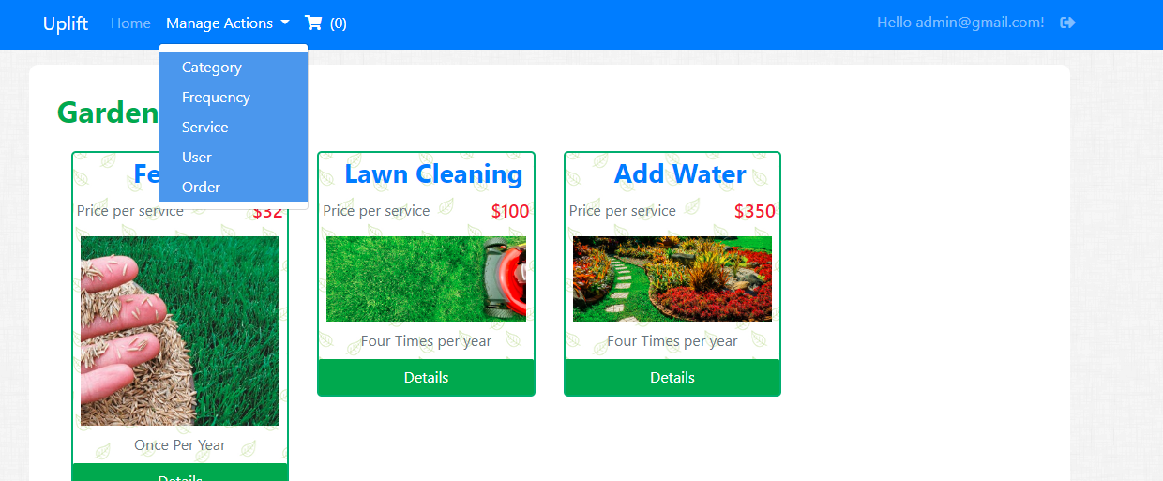

Category List

When user clicks “Category” from menu it is showing the list of all categories.

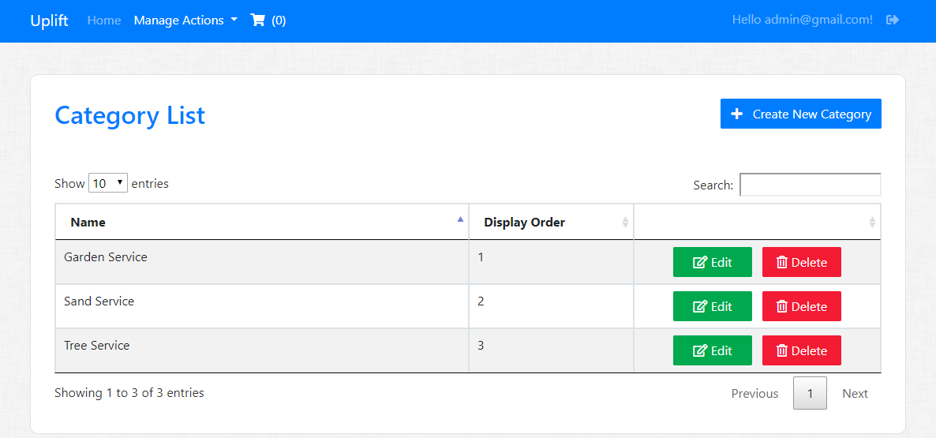

Searching Category from List

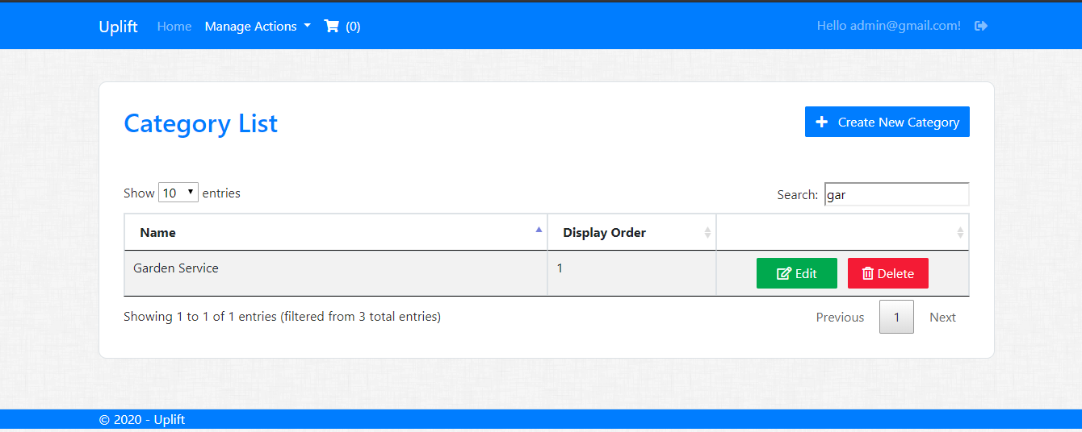

Create Category

By clicking “Create Category” button, below screen to add new Category.

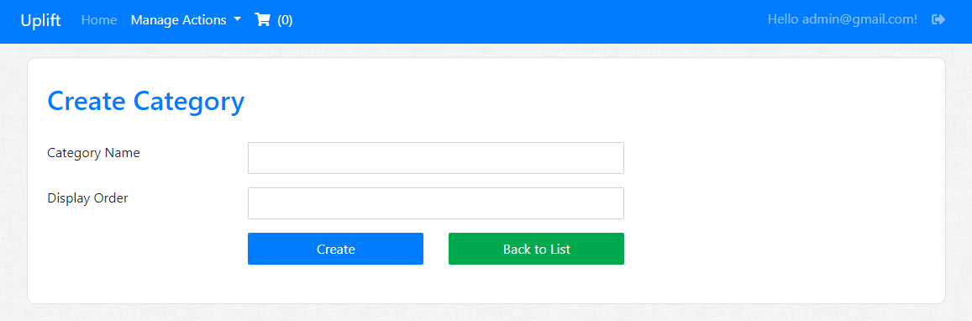

Validation check in Create Category.

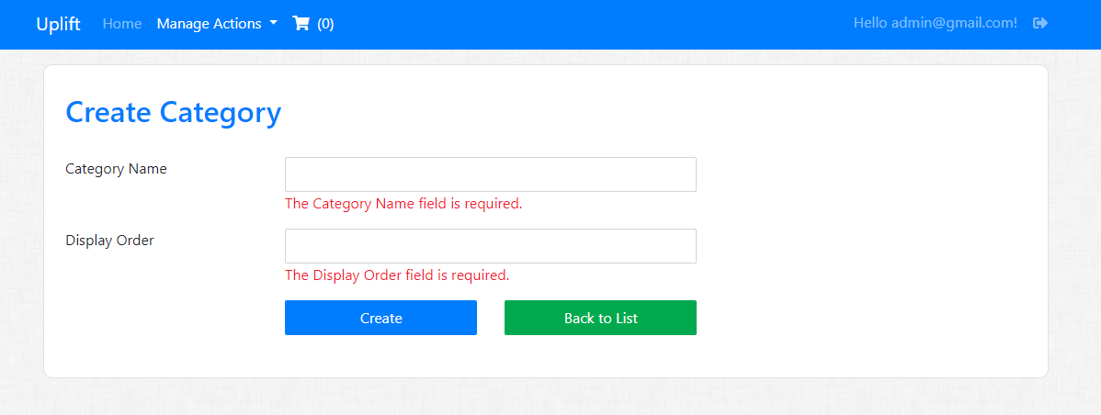

Edit Category

When user click on “Edit” button from Category List table.

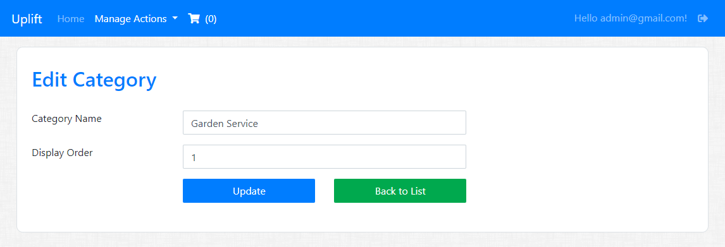

Delete Category

If user wants to delete Category, it shows a confirmation. By clicking “Yes, delete it” will delete the record.

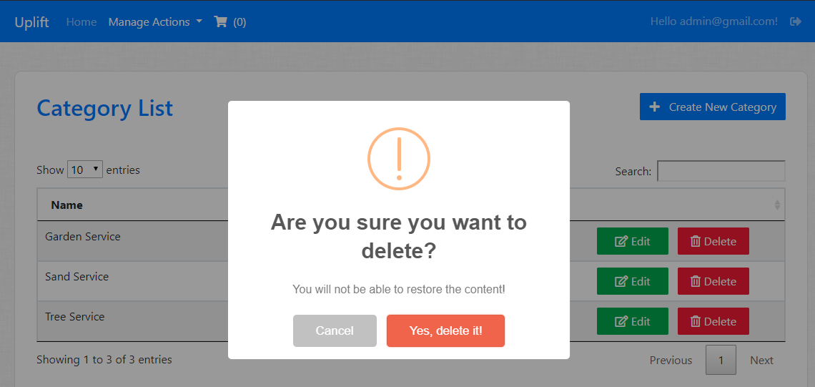

Successfully delete a Category

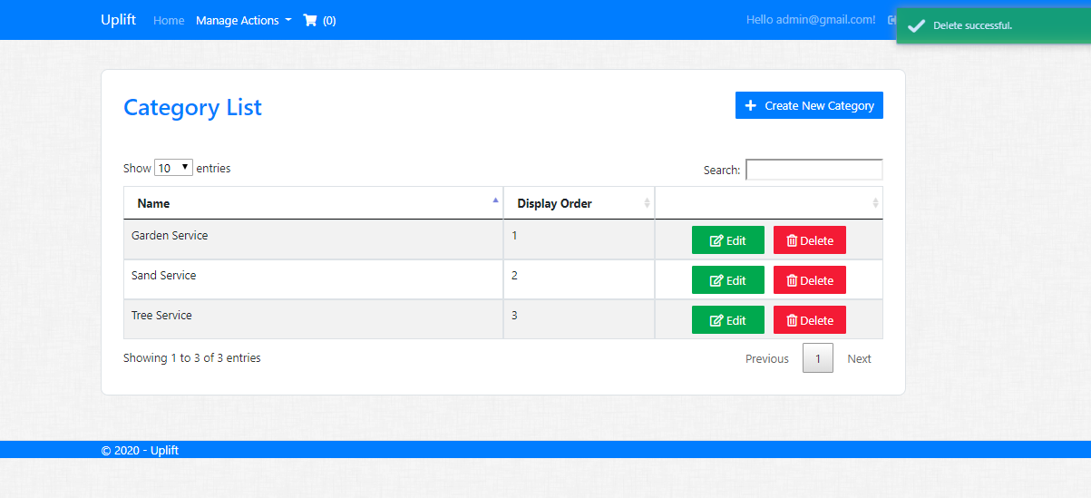

Frequency List

When user clicks “Frequency” from menu it is showing the list of all frequencies.

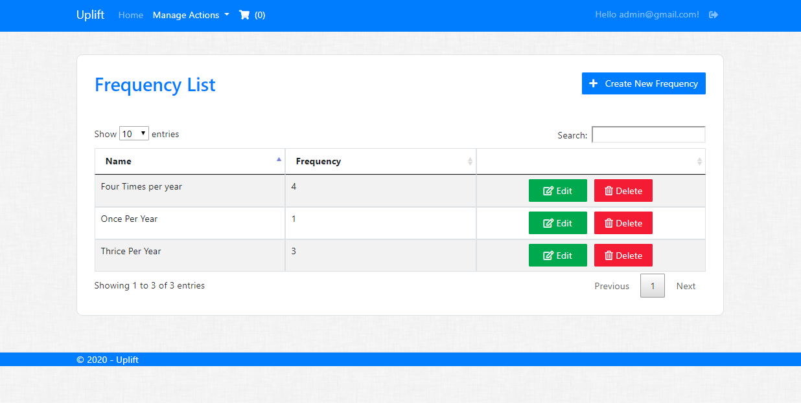

Searching a Frequency

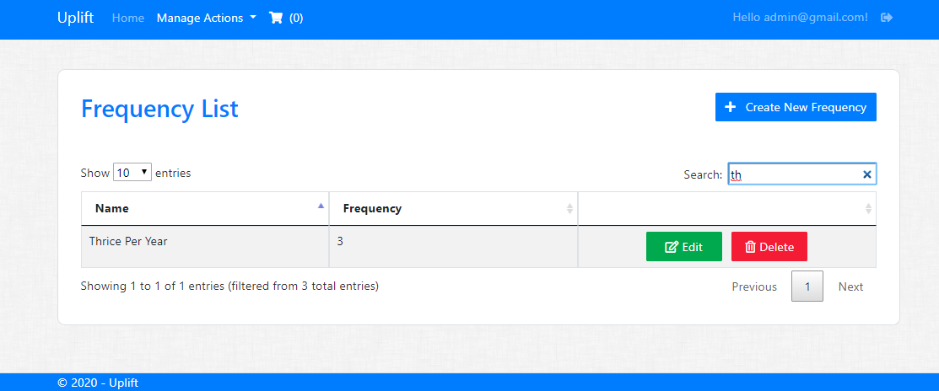

Add new Frequency

By clicking “Create New Frequency” button, below screen to add new Frequency.

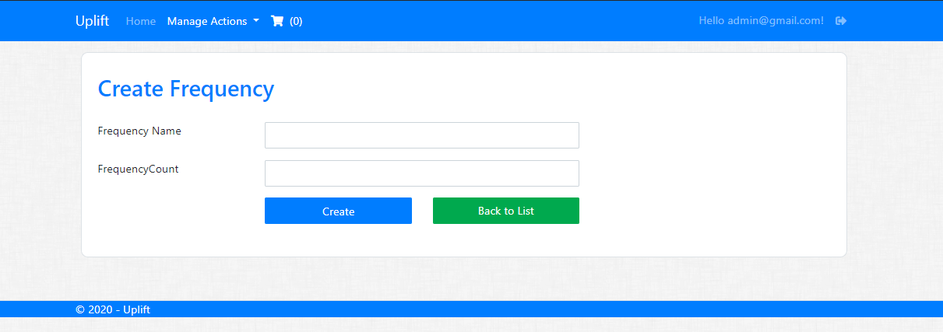

Validation check for Required

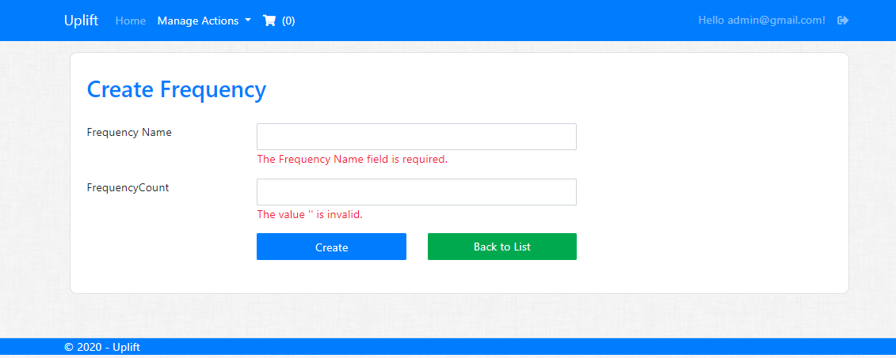

Edit Frequency

After “Update” or “Back To List” user goes to Frequency List.

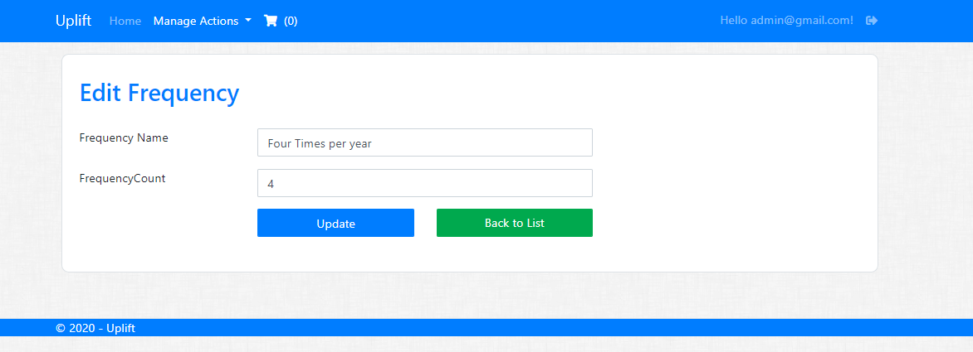

Delete Frequency

Below confirmation popup to delete Frequency when user clicks on “Yes, delete it”. “Cancel” button to close the popup.

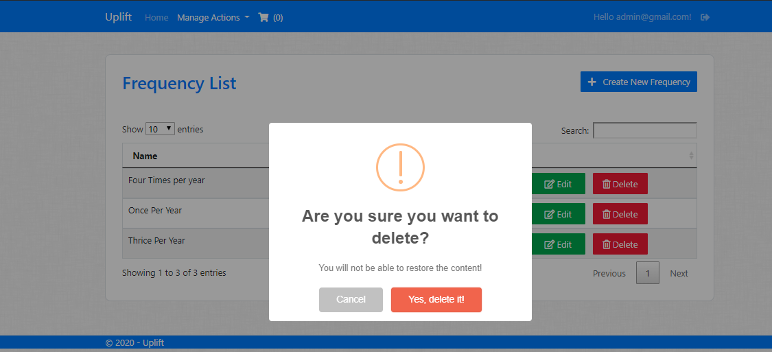

Service List

Service list to show the kind of service with price and frequency. User can Add, Edit and Delete services here.

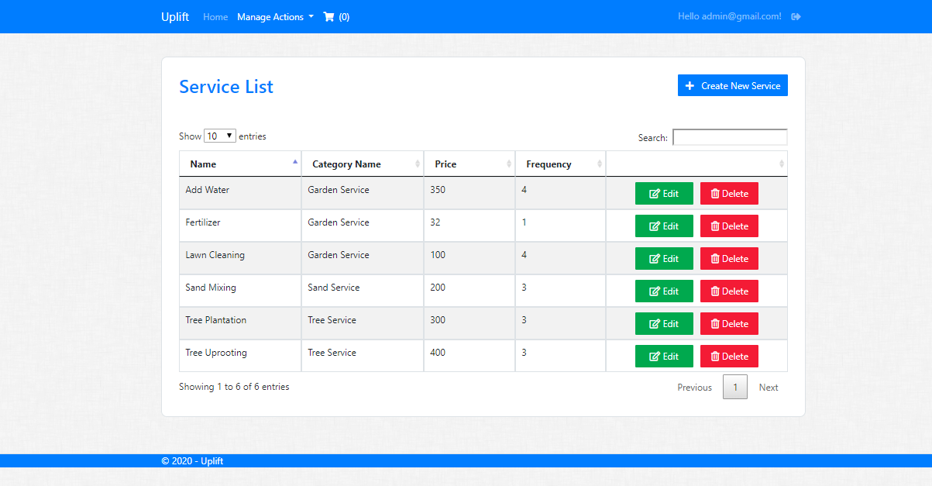

Searching from Service List

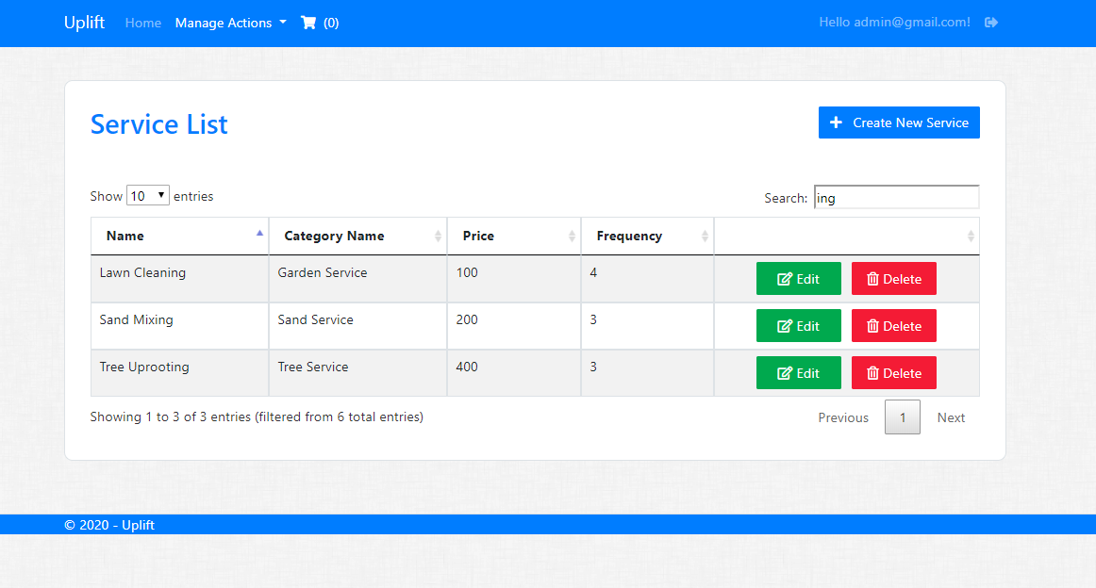

Creating New Service

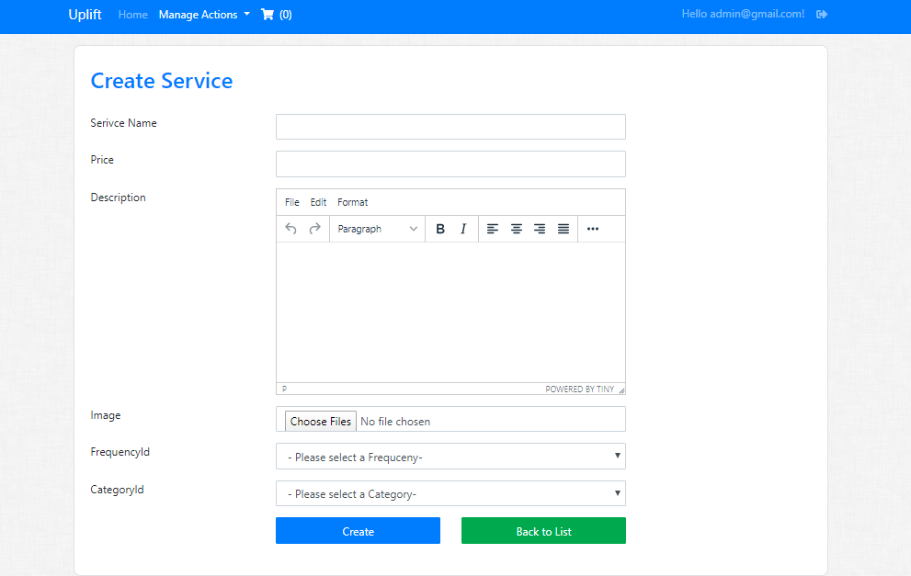

Editing the Service

Clicking “Update” or “Back to List” will redirect user to Service List.

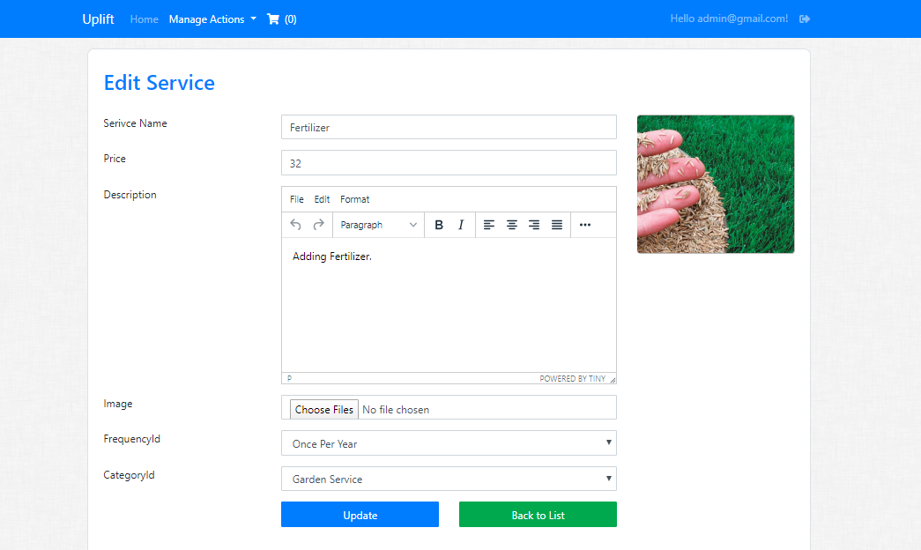

Employee List

From Menu user can come to Employee List by- Manage Actions -> User

Only Admin user having the access to this page and to perform action. “Admin” can add new user and can lock any user.

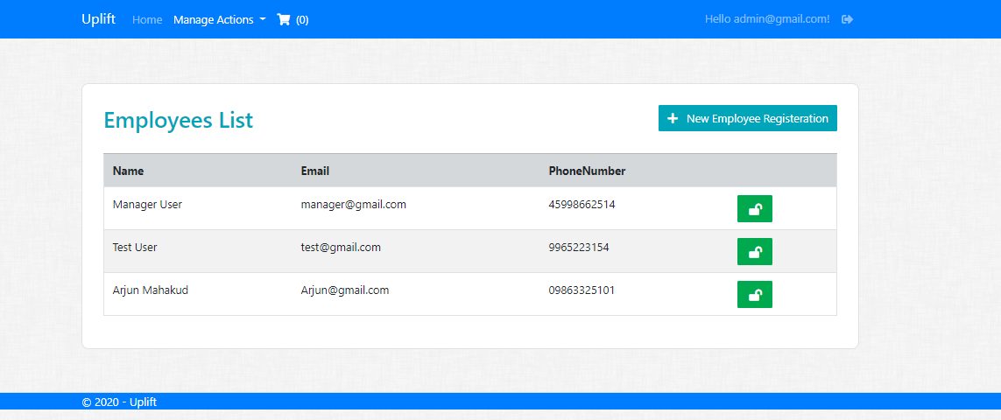

Clicking “New Employee Registration” will redirect user to below screen.

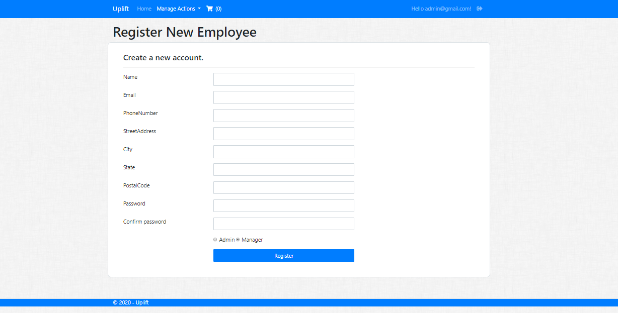

Locking User

Below one “Manager User” is locked and it changes to a lock symbol.

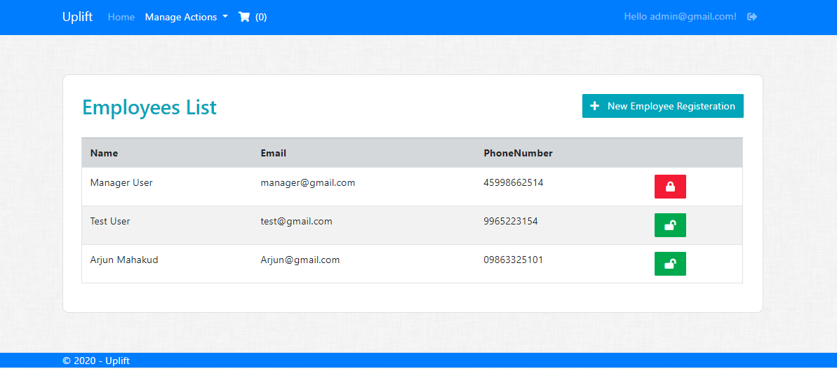

Locked user login

If “Locked” Manager User tries to log in, it shows below screen.

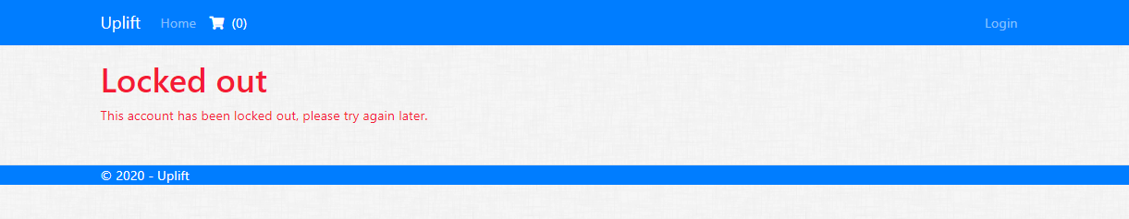

Order List

This is the list of order done by users. By default “All” tab selected to show all Pending, Approved ad Rejected Orders. Clicking “Pending” tab to show Pending orders and “Approved” to show Approved.

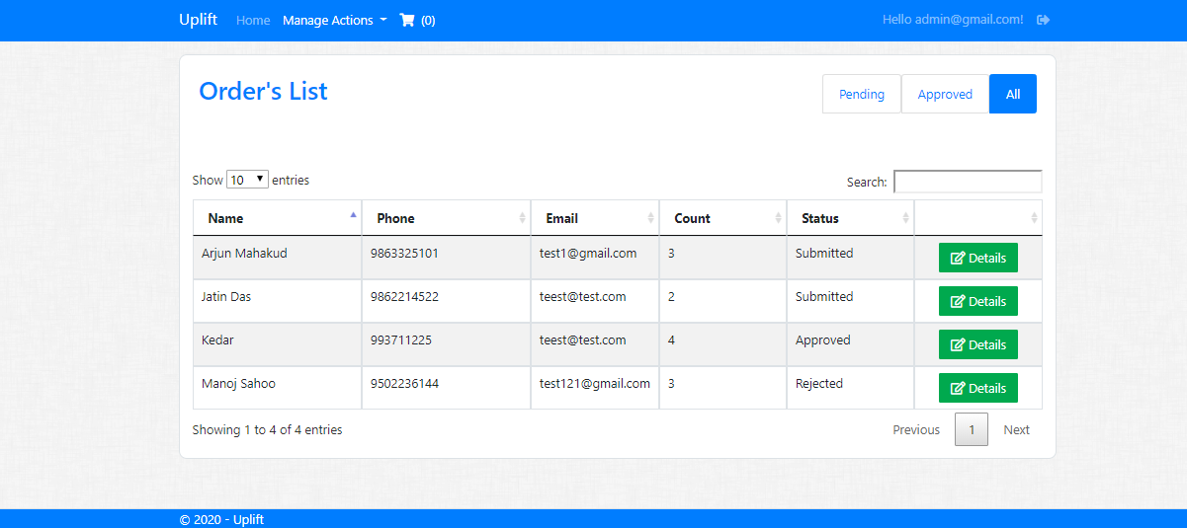

Pending orders

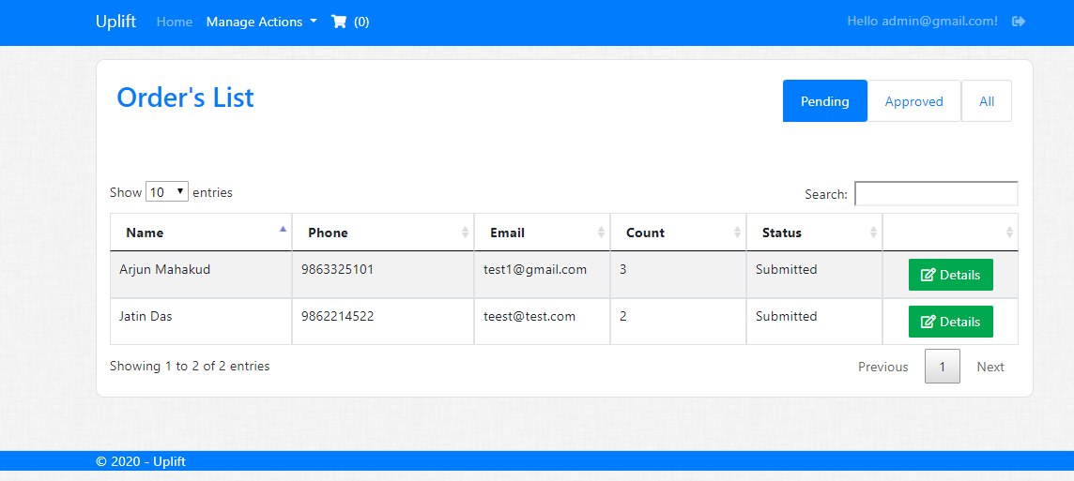

Approved Orders

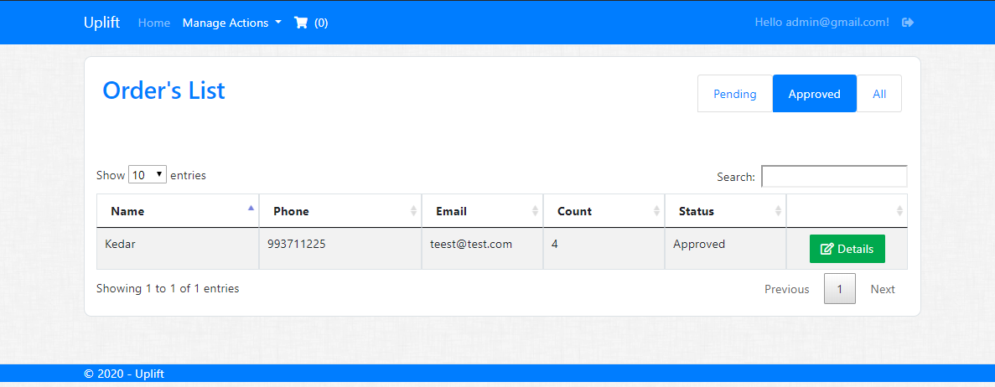

Searching from Order list

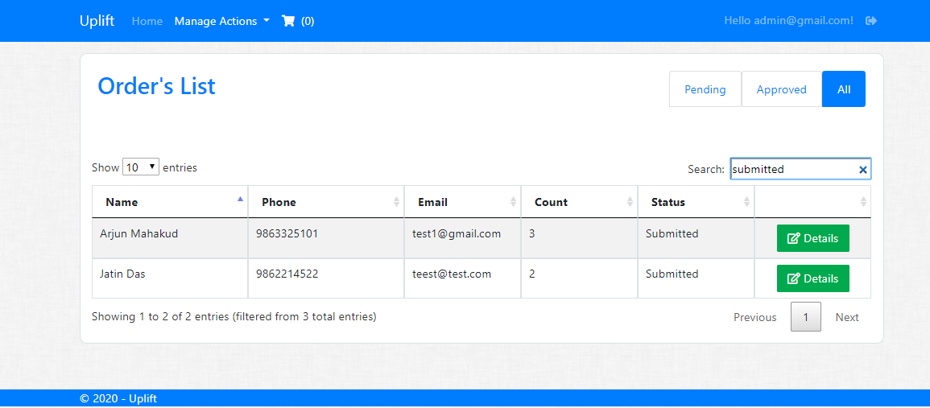

Details of Approved Order

By clicking “Details” of an Approved order will show the below screen. Here, it shows “Approved” below and “Back to List” in top right.

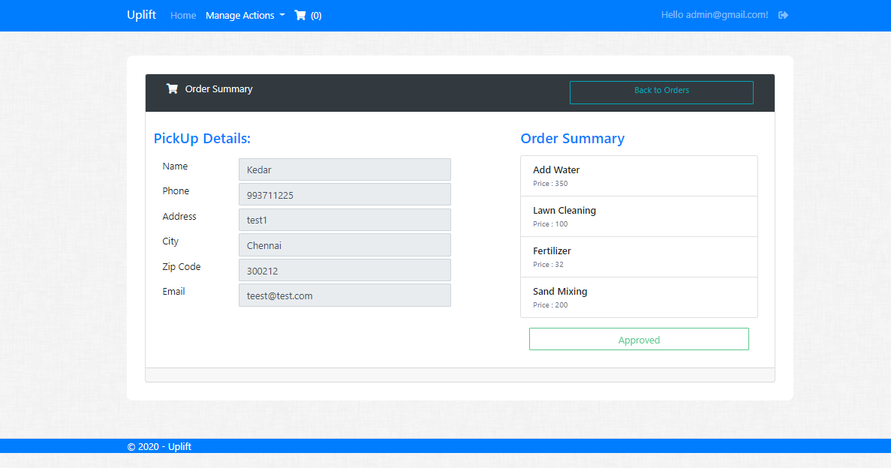

Details of Pending Order

By clicking “Details” of a Pending order, user can see both “Approve” and “Reject” button to approve the order or not.

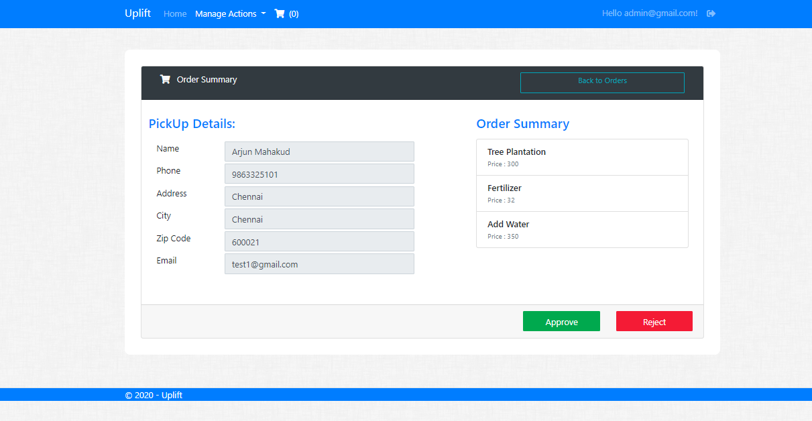

Menu Access for Manager Role

Manager can perform all operations like Admin user except “User” menu actions.

